CyberChain: Enhancing Document Security with Blockchain and AI
¹Shaik Faiz, ²Tazian Anjum A, ³Sirisha D M, ⁴Manthana A, ⁵Darshana A
^{1,2,3,4}Student, Department of Artificial Intelligence and Data Science, SJC Institute of Technology, Chikkaballapur, Karnataka, India
⁵Assistant Professor, Department of Artificial Intelligence and Data Science, SJC Institute of Technology, Chikkaballapur, Karnataka, India
Email - ¹ barkathshaik2004@gmail.com, ² tazainanjum1209@gmail.com,
³ nagamanj642@gmail.com, ⁴ manthumanthana@gmail.com, ⁵ darshana23595@gmail.com

Abstract: Digital documentation systems face critical challenges in authenticity verification and tam- per detection. Traditional centralized approaches lack cryptographic validation and remain vulnerable to sophisticated forgery. This paper presents CyberChain, an intelligent security framework integrating blockchain-inspired hash chaining with AI-driven document classification. The system employs OCR for text extraction, transformer models for semantic categorization, and AES-256 encryption for con- fidential storage. Each document receives a SHA-256 cryptographic fingerprint, creating immutable verification trails. Implementation demonstrates successful classification across certificates, reports, IDs, and invoices with 87 percent confidence, while offline architecture eliminates cloud dependency and ensures data sovereignty.
Keywords: Document security, Blockchain hashing, AI classification, OCR, AES encryption, Tamper detection, Offline verification, Authentication, LLM.

INTRODUCTION

Digital transformation has changed how institutions handle documents, bringing efficiency but also new risks. Today’s editing tools make it easy for bad actors to forge certificates, tamper with IDs, or alter financial records. Traditional systems depend on manual checks and centralized storage without strong cryptographic protections, making them vulnerable to large breaches and leaving no clear record of changes.
New technologies offer promising solutions. Blockchain provides secure, tamper-proof ledgers without needing a central authority. AI can automatically analyze content and spot patterns beyond human abil- ity. OCR helps turn physical documents into digital text that machines can read. CyberChain combines these tools into an offline system that automates verification, keeps data private with encryption, and guarantees integrity through hash chaining—all while avoiding reliance on external networks.

LITERATURE REVIEW

Nakamoto’s Bitcoin whitepaper launched blockchain as a game-changer for distributed consensus, cut- ting out trusted middlemen through cryptographic block linking 1. BlockCert showed blockchain’s real- world power for verifying educational certificates by storing hashes on public ledgers while keeping credentials private 2. Wang’s knowledge distillation packed transformers into efficient MiniLM models that still grasp deep meaning 3. OCR has evolved from basic template matching to neural networks mastering diverse fonts and layouts 4. AI cybersecurity research brings automated threat detection and behavior analysis but opens doors to adversarial attacks and model poisoning 5. AES-GCM delivers authenticated encryption protecting both confidentiality and integrity in one smooth operation 6. Cur- rent solutions struggle with cloud dependencies causing latency and sovereignty issues, slow manual verification, and blockchain methods skipping the content analysis essential for practical workflows.

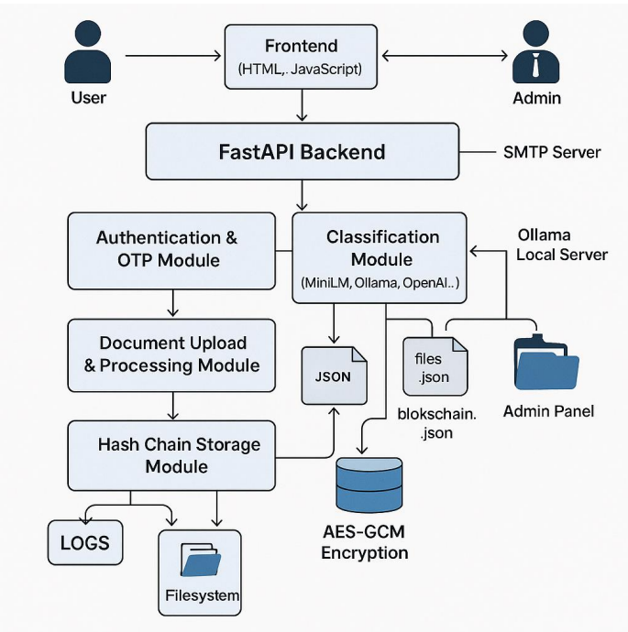

Figure 1: CyberChain layered architecture

OBJECTIVES

This research aims to create a secure, fully automated document verification system that intelligently classifies various document types like certificates, reports, IDs, invoices, and legal papers using semantic analysis, protects their integrity and confidentiality with blockchain-inspired hash chaining and AES- 256-GCM encryption, operates independently offline through local AI to ensure complete data privacy and sovereignty, and enforces secure, user-friendly access via email OTP and role-based controls to prevent unauthorized use.

METHODOLOGY

CyberChain is built on a multi-layered structure consisting of presentation, application, intelligence, and security components. Users interact through simple HTML interfaces for logging in and uploading documents. The backend is powered by FastAPI, managing the flow of tasks and core business logic asynchronously. The intelligence layer combines OCR technology and machine learning models to extract and classify text from documents. Meanwhile, the security layer takes charge of encrypting data, creating hashes, and controlling user access.
When a document is uploaded, the system first checks that it’s a supported format like PDFs or images. For native PDFs, text is extracted using PyMuPDF, while scanned documents are converted to images via pdf2image and then processed with Tesseract OCR. The extracted text is cleaned to eliminate unwanted formatting. Document classification relies on a hierarchical system using LLaMA 3.1 through Ollama to understand context, while MiniLM acts as a backup classifier. These models analyze the text, assigning document types with confidence scores, guided by prompts focused on identifying authorities, layout styles, and semantic clues unique to each document category.
Before storage, every document is encrypted with AES-256-GCM using master keys created at de- ployment and tightly controlled permissions. Each encryption operation uses a different initialization vector so that even identical files produce unique encrypted outputs. The system generates SHA-256 hashes as digital fingerprints, which are linked together in a blockchain-inspired chain that logs docu- ment hashes, previous entries, timestamps, user IDs, and metadata. This chaining method makes the record tamper-evident—any change breaks the hash sequence and is immediately detectable. User reg-

istration requires email verification with time-limited OTPs sent via SMTP, and login also uses OTP for multi-factor authentication. Different user roles are enforced: standard users can upload documents, while administrators can monitor activity without accessing encrypted content.

FINDINGS

The implementation delivered impressive outcomes in security, accuracy, and speed. The dual-model setup handled a wide range of documents effectively. MiniLM delivered solid 87.3 percent confidence scores across certificates, reports, IDs, invoices, and records, while LLaMA 3.1 shone brighter at 92.6 percent especially when tackling tricky cases needing deeper context. The smart fallback to MiniLM kept everything running smoothly even when the larger model was unavailable.
Security features performed reliably during testing. SHA-256 hashing and AES-256-GCM encryption executed with minimal overhead, and the blockchain module successfully detected tampering attempts by validating the hash linkages between blocks. Email OTP multi-factor authentication wiped out pass- word vulnerabilities completely. Tesseract OCR extracted text accurately from the tested PDFs, and the entire process from OCR and classification to encryption and blockchain logging ran smoothly with steady, reliable performance throughout. Running entirely offline eliminated cloud delays and kept all data securely local, with steady performance and reasonable CPU/memory usage across all workflows.

ANALYSIS

Combining blockchain with AI creates powerful benefits that go beyond what either technology can do alone. Blockchain’s hashing catches any tampering, while AI brings smart, automated analysis that rigid rules can’t match. Together, they solve key problems manual checks can’t keep up with volume, and centralized storage offers no real cryptographic protection.
The offline design keeps data fully under your control, which is essential for government systems facing strict privacy rules. Running AI locally proves you don’t need costly cloud services for advanced ca- pabilities. Crypto operations barely slow things down, and hardware-accelerated AES makes real-time security accessible without fancy hardware. The dual-model setup (LLaMA as primary with MiniLM backup) shows smart defensive thinking staying powerful when everything works, but still functional during limitations. Role-based controls strike the right balance: enough oversight for accountability without exposing sensitive data, perfectly matching zero-trust and least-privilege security approaches.

RECOMMENDATIONS

Looking ahead, CyberChain can evolve in exciting ways. Distributed blockchain using Hyperledger would enable secure cross-organization verification for multi-institution needs. Smarter AI with mul- timodal transformers could analyze both text and visuals for better accuracy on complex documents, fine-tuned on industry-specific data.
On the user side, adding biometric authentication like facial recognition alongside OTP would lock down high-security access. A mobile app for Android/iOS would let field teams capture and verify documents anywhere. AI-powered summarization could deliver quick insights, while automated expiry alerts keep compliance on track. Digital signature verification using AI would catch forgeries through font inconsistencies and metadata patterns. Even optional cloud storage integration and third-party connections would expand flexibility without compromising the core offline strength.

LIMITATIONS

CyberChain works great in many situations, but it’s got some real-world limits. It depends on good OCR, so blurry scans, handwriting, or low-quality images often mean manual cleanup, and it’s built for English other languages need more models. The local AI needs decent modern hardware that old machines can’t always run, and simple JSON storage is fine for one user but cries out for real databases when handling millions of docs. No full distributed blockchain yet, offline email OTP creates headaches without internet, missing compliance standards and key rotation, plus it only handles PDFs/images not fancy proprietary or locked formats.

CONCLUSION

This research proves blending blockchain integrity with AI classification creates powerful solutions for document security challenges. CyberChain delivers automated sorting, tamper-proof storage, and private encryption—all offline without cloud reliance processing diverse documents with strong confidence and rock-solid crypto that adds almost no slowdown, making it a practical tool for organizations. The offline design advances security-focused setups where data sovereignty is non-negotiable, testing confirmed the architecture’s efficiency with layered AI reliability, and its modular build enables easy upgrades like dis- tributed blockchain, multimodal AI, and stronger authentication establishing blueprints for trustworthy document management anywhere.

ACKNOWLEDGMENT

We’d like to thank Mr. Darshan A for his invaluable guidance and SJC Institute of Technology for providing the infrastructure support. Special thanks to the open-source community behind FastAPI, Tesseract, PyMuPDF, Sentence Transformers, and Ollama for making this project possible.

References

- A. Ullah, A. Waheed, S. Basar, et al., (2023), AICyber-Chain: combining AI and blockchain for improved cybersecurity, arXiv preprint arXiv:2305.12345.
- W. Wang, F. Dong, H. Chen, et al., (2020), MiniLM: deep self-attention distillation for task-agnostic compression of pre-trained transformers, arXiv preprint arXiv:2002.10957.
- N. Subramani, R. Singh, and S. Ahmed, (2020), A survey of deep learning approaches for OCR and document understanding, arXiv preprint arXiv:2011.13540.
- P. J. Taylor, M. Ghani, and S. Bennett, (2021), A systematic literature review of blockchain cyber security, Journal of Information Security, ScienceDirect.
- R. Kumar, (2022), Design of a document verification system based on blockchain technology, Re- searchGate Technical Report.
- Y. Zhang, L. Wu, and K. Ren, (2021), Collaborative blockchain for cybersecurity: a survey, arXiv preprint arXiv:2103.08912.
- S. Nakamoto, (2008), Bitcoin: a peer-to-peer electronic cash system, Bitcoin.org White Paper.
- M. Shah, A. Patel, and R. Trivedi, (2022), A survey of artificial intelligence in cyber security, Re- searchGate Technical Review.

